Use the naming rules you have learnt to answer the following questions.

1. 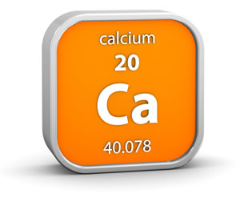Compounds that contain oxygen and one other element are called oxides.

Name these oxides: (3)

* 1. MgO _______________________________
  2. CaO _______________________________
  3. Na2O _______________________________

1. Some oxides contain more than one oxygen atom. Name these oxides: (3)
   1. CO2 _______________________________
   2. SO2 _______________________________
   3. SO3 _______________________________
2. 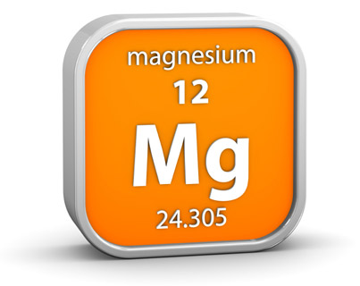Compounds that contain sulfur and one other element are called sulfides.

Name these sulfides: (3)

* 1. FeS _______________________________
  2. ZnS _______________________________
  3. H2S _______________________________

1. Compounds that contain chlorine and one other element are called chlorides.

Name these chlorides: (3)

* 1. KCl _______________________________
  2. NaCl _______________________________
  3. HCl _______________________________

1. 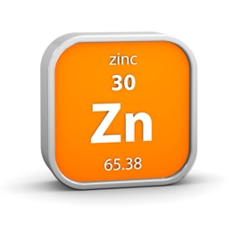Compounds that contain oxygen, sulfur and one other element are called sulfates.

Name these sulfates: (3)

* 1. CuSO4 _______________________________
  2. ZnSO4 _______________________________
  3. Na2SO4 _______________________________

1. Compounds that contain oxygen, carbon and one other element are called carbonates.

Name these carbonates: (3)

* 1. CuCO3 _______________________________
  2. Na2CO3 _______________________________
  3. MgCO3 _______________________________

1. 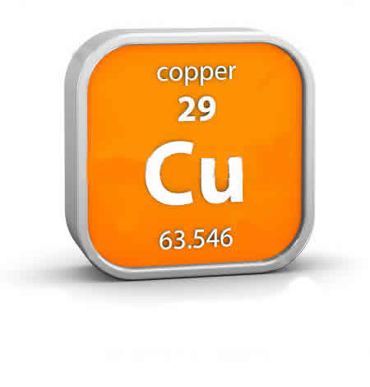Compounds that contain oxygen, nitrogen and one other element are called nitrates.

Name these nitrates: (3)

* 1. NaNO3 _______________________________
  2. KNO3 _______________________________
  3. AgNO3 _______________________________

1. Now you've got the hang of it, try naming these compounds: (12)
   1. LiCl ____________________ g. CaCO3 ____________________
   2. MgSO4 ____________________ h. K2SO4 ____________________
   3. Li2O ____________________ i. RbNO3 ____________________
   4. CaS ____________________ j. CaCl2 ____________________
   5. ZnO ____________________ k. NiS ____________________
   6. LiNO3 ____________________ l. K2CO3 ____________________

*Extension:*

1. These may look a bit different, but you can use the same rules. Try naming them: (4)
   1. Al2O3 ____________________ c. Al2(SO2)3 ___________________
   2. Zn(NO3)2 ____________________ d. Al2(CO3)3 ___________________
2. Suggest names for these compounds: (4)
   1. KBr ____________________ c. AlPO4 ___________________
   2. 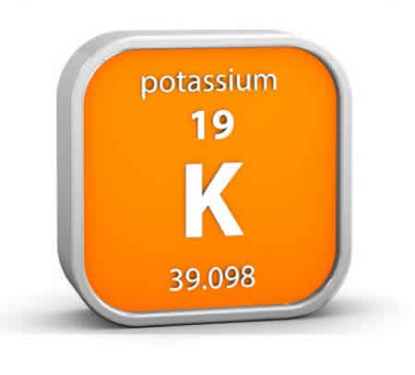BN____________________ d. NaHCO3 ___________________
3. Look up the names of these compounds: (2)
   1. KMnO4 _______________________________
   2. K2CrO4 _______________________________
4. Try to explain the names of the compounds in Q11. (6)
   1. ________________________________________________________________________________________________________________________________________________________________________

________________________________________________________

* 1. ________________________________________________________

________________________________________________________

________________________________________________________

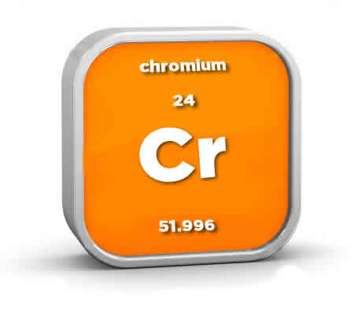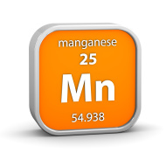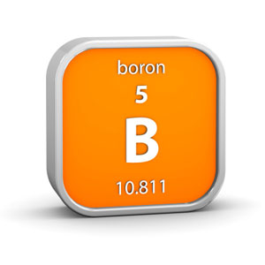________________________________________________________

Use the naming rules you have learnt to answer the following questions.

1. Compounds that contain oxygen and one other element are called oxides.

Name these oxides: (3)

* 1. MgO _______________________________
  2. CaO _______________________________
  3. Na2O _______________________________

1. Some oxides contain more than one oxygen atom. Name these oxides: (3)
   1. CO2 _______________________________
   2. SO2 _______________________________
   3. SO3 _______________________________
2. Compounds that contain sulfur and one other element are called sulfides.

Name these sulfides: (3)

* 1. FeS _______________________________
  2. ZnS _______________________________
  3. H2S _______________________________

1. Compounds that contain chlorine and one other element are called chlorides.

Name these chlorides: (3)

* 1. KCl _______________________________
  2. NaCl _______________________________
  3. HCl _______________________________

1. Compounds that contain oxygen, sulfur and one other element are called sulfates.

Name these sulfates: (3)

* 1. CuSO4 _______________________________
  2. ZnSO4 _______________________________
  3. Na2SO4 _______________________________

1. Compounds that contain oxygen, carbon and one other element are called carbonates.

Name these carbonates: (3)

* 1. CuCO3 _______________________________
  2. Na2CO3 _______________________________
  3. MgCO3 _______________________________

1. Compounds that contain oxygen, nitrogen and one other element are called nitrates.

Name these nitrates: (3)

* 1. NaNO3 _______________________________
  2. KNO3 _______________________________
  3. AgNO3 _______________________________

1. Now you've got the hang of it, try naming these compounds: (12)
   1. LiCl ____________________ g. CaCO3 ____________________
   2. MgSO4 ____________________ h. K2SO4 ____________________
   3. Li2O ____________________ i. RbNO3 ____________________
   4. CaS ____________________ j. CaCl2 ____________________
   5. ZnO ____________________ k. NiS ____________________
   6. LiNO3 ____________________ l. K2CO3 ____________________

*Extension:*

1. These may look a bit different, but you can use the same rules. Try naming them: (4)
2. Al2O3 ____________________ c. Al2(SO2)3 ___________________
3. Zn(NO3)2 ____________________ d. Al2(CO3)3 ___________________
4. Suggest names for these compounds: (4)
   1. KBr ____________________ c. AlPO4 ___________________
   2. BN____________________ d. NaHCO3 ___________________
5. Look up the names of these compounds: (2)
   1. KMnO4 _______________________________
   2. K2CrO4 _______________________________
6. Try to explain the names of the compounds in Q11. (6)
   1. ________________________________________________________________________________________________________________________________________________________________________

________________________________________________________

* 1. ________________________________________________________

________________________________________________________

________________________________________________________

________________________________________________________